- Write a query that produces all rows from the Customers
table for which the salesperson’s number is 1001.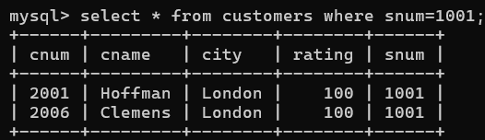

- Write a select command that produces the rating followed
by the name of each customer in San Jose.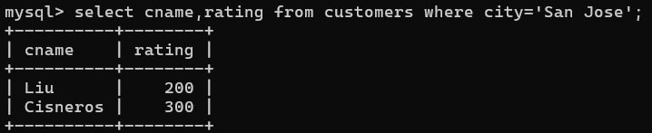

3. Write a query that will produce the snum values of all
salespeople from the Orders table (with the duplicate values
suppressed).
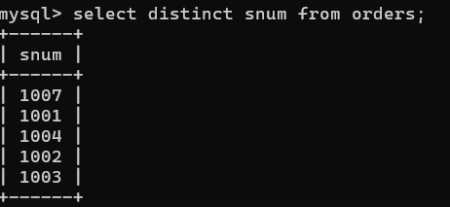

4. Write a query that will display all the orders for amount
more than Rs. 1,000.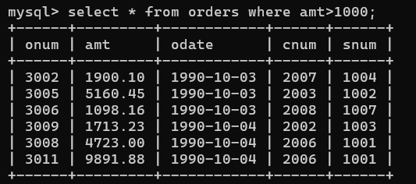

5. Write a query that will give you the names and cities of
all salespeople in London with a commission above 0.10.
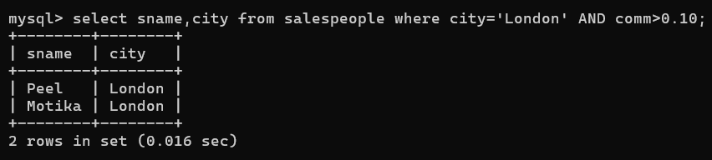

6.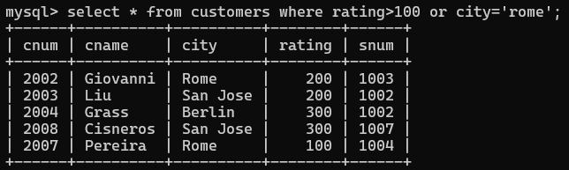

7.
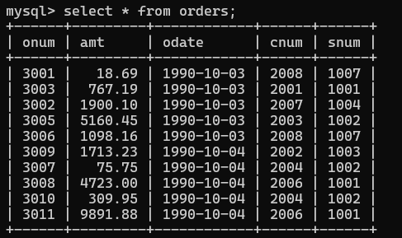

8.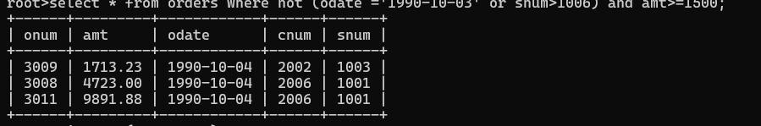

9.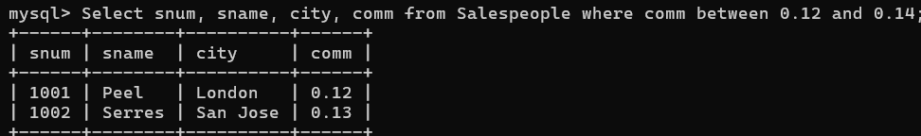

10.
